

# Certificate in Computing

Review the Attached Lab Demonstration explaining by example SPF and FIFO Algorithms

Complete the following Process scheduling Algorithm task for both FCFS and SPF calculating Turn around time and Response Times.

Then Calculate the **Average** for Both e.g.

**Avg Turnaround = (3 + 7 + 11 + 16 + 3) / 5 = 8.0 time units**

Excel Worksheet Attached to Assist in listing processes.

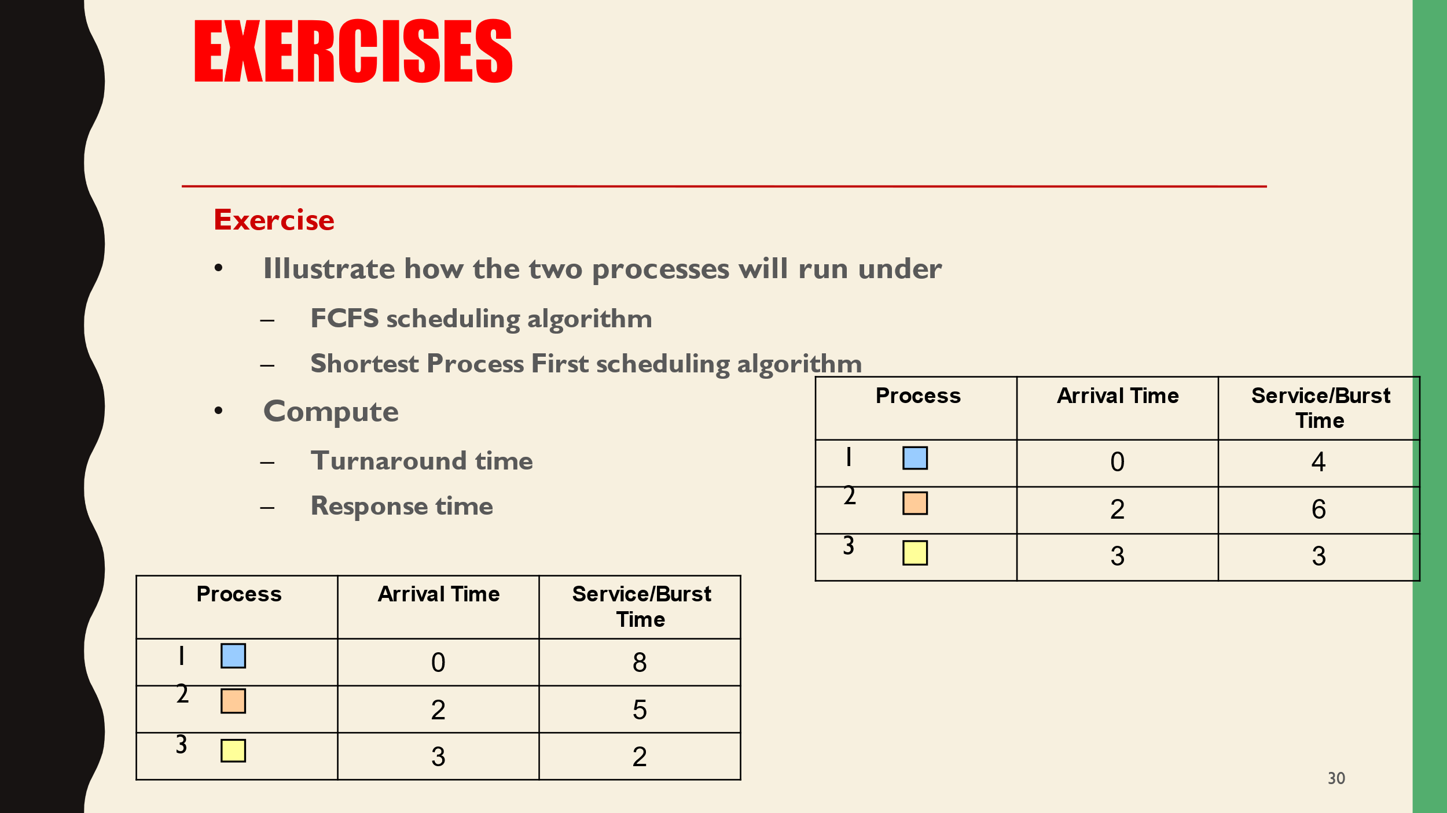

|  |  |  |
| --- | --- | --- |
| **Process** | **Arrival Time** | **Service/Burst Time** |
| 1 | 0 | 4 |
| 2 | 2 | 6 |
| 3 | 3 | 3 |

|  |  |  |
| --- | --- | --- |
| **Process** | **Arrival Time** | **Service/Burst Time** |
| 1 | 0 | 4 |
| 2 | 2 | 6 |
| 3 | 3 | 3 |

Upon Completion of the Above

Investigate Process / Task Manager on your own machine, detail the high priority tasks and explain – as shown in Task Manager.